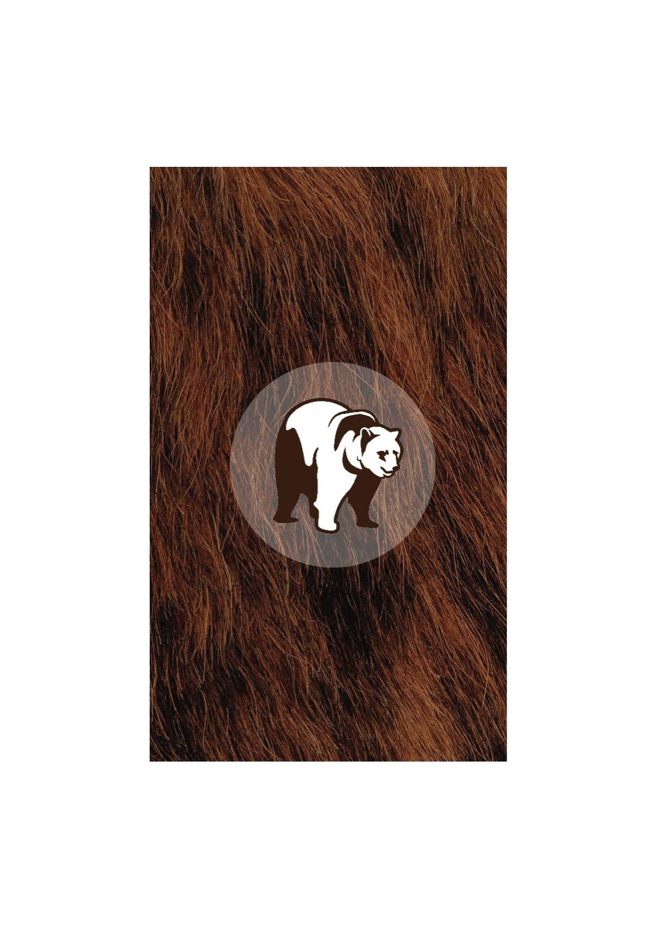



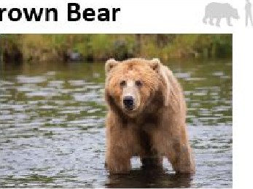
Giraffe
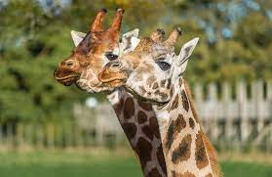Origin: Sun-Sahara Africa
Terrain: Grassland and Open Woodland
Life Span: up to 26 years in the wild
Height: Males up to 5.5 meters, females 4.5 meters
Weight: Males up to 1,930 kg and Females up to 1,180kg
Diet: Leaves & buds on trees/shrubs, flowers, and fruit

Giraffes can be any of four species and are the tallest of all land animals. They use their flexible black tongues, which are almost a meter long to eat up to 65kg of food per day. They have horns and can reach speeds up to 37 miles per hour. They live in groups of up to 20 and have excellent eyesight. They are one of the tallest mammals and have the longest tail of any land mammal.

The Giraffes in Blair Drummond are all female their names are Harriet, Ruby and Bella. They are Hybrids, so their coat patterns are easily distinguishable.

Grant’s Zebra
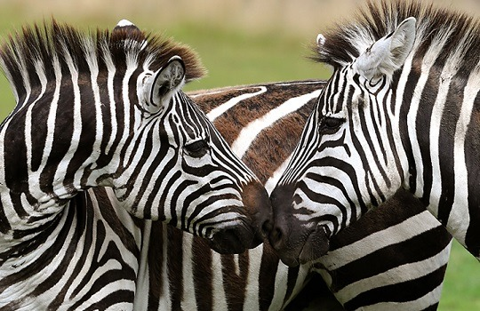Origin: East and South Africa
Terrain: Treeless grassland and savanna woodlands
Life Span: Up to 20 years in the wild and 40 in zoos
Height: 56 inches tall
Weight: 800 pounds
Diet: Coarse grasses, leaves, bark, shrubs
Grant’s Zebras have varying stripes which each individual having different patterns. They mostly spend their day grazing. Grant’s Zebras spend most of their time eating and are highly social. They frequently change herd structure and will change companions every few months.

Grant’s Zebras in Blair Drummond are called, Tanu & ABBA, they have recently been introduced but have already formed a strong bond.

Amur Tiger
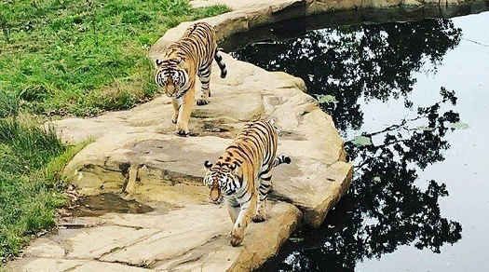Origin: Russian Far East and China
Terrain: Mountain Forests
Life Span: 10-15 years in the wild, 20-25 years in captivity
Height: 10 feet long
Weight: up to 450 pounds
Diet: Wild boar, deer, badgers, racoons, and bears
Amur or Siberian tigers are a rare sub-species of tiger and the heaviest and largest cats in the world. They have thick coats than other tigers to live in colder climates with thick fur around their paws and neck. They are typically solitary animals, marking their scent on trees to keep other tigers away and roam many miles to often hunt.

The Amur tigers in Blair Drummond are a female and male. Hope the female is 8 years old and has gorgeous love heart markings above her eyes she is very active and likes to climb trees. Vitali our male is very big and stocky, he is 6 years old and enjoys spending time cooling off in the mud or in the water.

African Lion
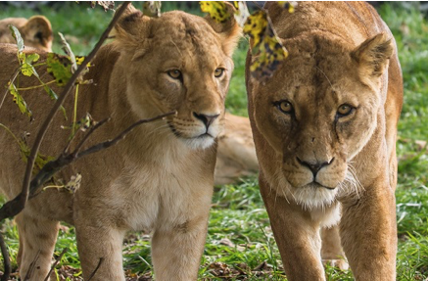Origin: sub-Saharan Africa
Terrain: grassland, savanna, scrub, open woodlands
Life Span: 8-15 years in the wild, up to 20 in captivity
Height: 90-120 cm
Weight: 130-190 kg
Diet: zebra, wildebeest, rodents, and reptiles
African Lions are the most social of all big cats, living in groups called prides. They are the top predators in their environment. They play a crucial role in keeping a healthy balance of numbers amongst other animals. Lion cubs are reared together. They can eat up to 40kg of meat in a single meal. Their tongues have sharp-pointed rasps used to scrape meat.

The eight African lions in Blair Drummond are all related to each other. There are two adult females, sisters, and have offspring from the male. Their names are Libby (the oldest) & her Cubs Hope & Faith born in 2019. Karis is the second oldest & her cubs Isla, Thistle, Murray & Reid were born in 2016. they are all social and get on well with each other.

African Elephant
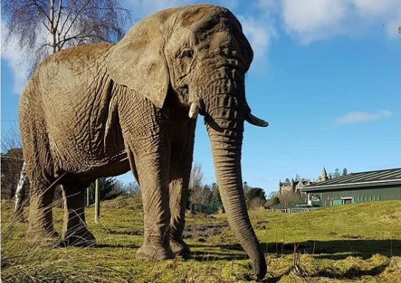
Origin: sub-Sahara Africa
Terrain: wetlands, forest, grassland, savanna, and desert
Life Span: 60-70 years
Height: 3.2 meters
Weight: up to 6 tons
Diet: grasses, bark, twigs, roots, leaves, fruits, and vegetables
Elephants are the world’s largest mammal. Their trunk is an extension of their nose and upper lip and contains an incredible 40,000 different muscles. The trunk is used for breathing and smelling, but also as a tool like your arm. They are highly social.

The Elephant in Blair Drummond is Mondy, an older female of 53 years. Part of her daily routine is she gets hosed with warm water which encourages her to use the mud wallow and dust bath. Mondy is trained every day for keepers. Her favourite food is Bamboo and Willow.

Chimpanzee
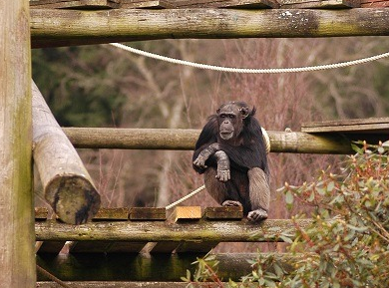
Origin: Central and Southern Africa
Terrain: savanna woodlands, grasslands, and forests
Life Span: 15-30 years in the wild, up to 60 in captivity
Height: 1-1.7 meters when standing
Weight: 32-60 kg
Diet: fruit, roots, nuts, leaves, plants, flowers, insects, and meat
Chimpanzees are highly intelligent and form complex social relationships. In the wild they live in groups between 20 and 100 individuals. They are extremely expressive and use their facial expressions to communicate. They can solve simple problems and are able to use tools, such as sticks.

The Chimpanzees in Blair Drummond are two females, Copper, (34) and Jill (53) and one male Chippy (35). Copper loves her food, especially fruit, she is a very smart and independent chimp. Gill enjoys interacting with the keepers during training sessions. Chippy (35) is the group's leader, he was born in the park.

Black-and-White Lemurs
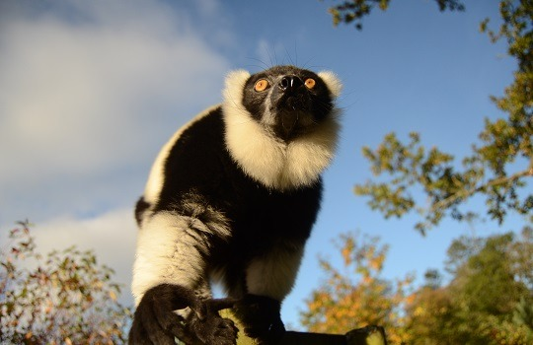Origin: Madagascar
Terrain: middle and upper part of the rainforest
Life Span: 20-25 years in captivity and 18-20 in the wild
Height: 20 to 22 inches
Weight: 6.6- 20 pounds
Diet: Leaves, shoots, flowers and fruits

Black-and-White Lemurs are one of the largest of the lemurs. They have long tails, of up to two feet which is used for balance. They have grasping fingers to climb and semi-opposable thumbs in their hands, able to hang upside down. They spend most of their day traveling, grooming, and resting. They have loud calls, to communicate, signal their presence, display dominance, or sound the alarm. They live in groups of up to 8 to 16 individuals.

The Lemurs in Blair Drummond consist of a group of older females and males, as well as some recent babies. The Lemurs enjoy playing and will stretch out their arms when it gets warm.

California Sea Lion
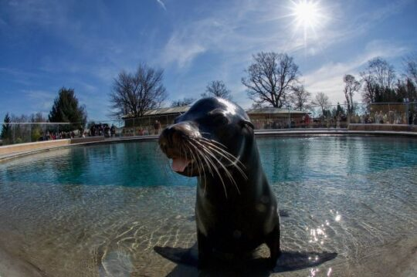
Origin: West Coast of North America
Terrain: Coastlines and islands of the ocean
Life Span: 15-20 years in the wild, 25-30 in captivity
Height: up to 8 feet
Weight: 600 pounds
Diet: squid, anchovies, mackerel, rockfish, and sardines
California sea lions are playful, curious, and excellent athlete in the water. They are capable of swimming at high speeds and communicate with each other underwater by sounds using air in their lungs. During breeding season, the males guard and defend their territory over other males. Sea lions are highly social and can be trained to do various tasks. They can hunt by pushing fish into a tight circle in groups.

The California sea lions in Blair Drummond Oscar (7) Ineke (7) Luce (6) & Poppy (18) she will be 19 on the 4th of June. They have a new pool and enjoy basking and porpoising.

