Psychophysics of Dogs

Olfaction (smell)
- Most developed sense.
- Can push air through different parts of their nose to smell on different “levels”.
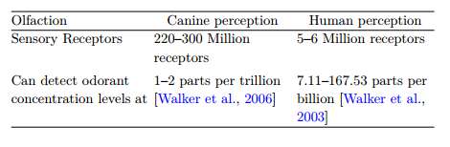
(Table 3.1; Freil et al., 2016. Canine Centred Computing. Foundations and Trends in Human-Computer Interaction. Vol 10. 87)
Hearing
- Second most developed sense.
- Wide range of frequencies which diminish with age.
- Changes with the dogs’ ear shape!
- Can hear higher frequencies.
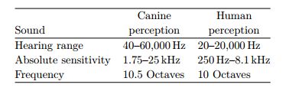
(Table 3.2; Freil et al., 2016. Canine Centred Computing. Foundations and Trends in Human-Computer Interaction. Vol 10. 87)

Vision
- See better in dim lighting (higher sensitivity to light)
- Range of view varies across breed from 240 – 250 degrees having a larger field of view than humans (180 degrees).
- Dogs are not as good as humans with depth perception.
- Different colour perception (dichromatic)

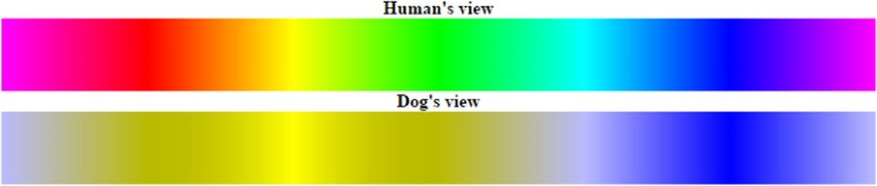
A full RGB spectrum showing how the same colour line would be perceived by a dog (Peter, 2013).

Somatic sensation (skin)
- Dogs mostly covered in hair.
- On dogs, hairy skin (Tylotrich) reduced perception compared to human skin.
- Coat types and densities reduce nerve resolution which affects precision of touch.
- Footpads on dogs have sensory abilities to explore objects.
- Dogs whiskers highly sensitive extending their vision like regular hairs.

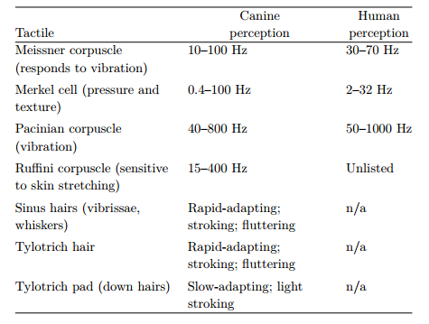
(Table 3.; Freil et al., 2016. Canine Centred Computing. Foundations and Trends in Human-Computer Interaction. Vol 10. 87)

